**SAP Implementation Project**

**At**

**Government of Andhra Pradesh**

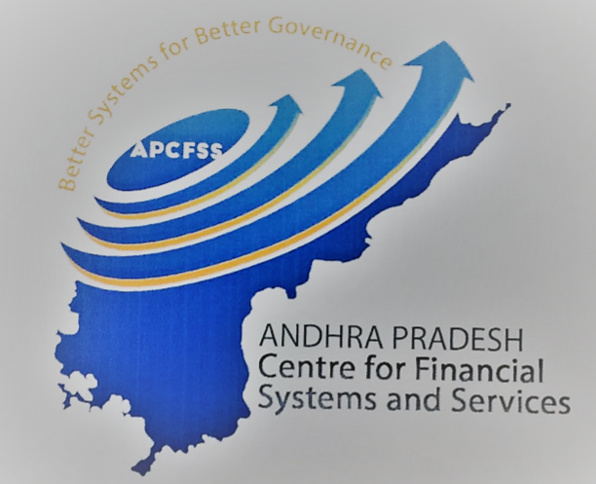

**Project CFMS**

**(Comprehensive Financial Management System)**

**Technical Design Document**

**BILL SUMMARY REPORT**

Document Version : 1.1

Document Release Date : 01st, October, 201819.08.03 13:02

**Only for internal use**

Table of Content

1. Introduction 2

1.1 Purpose of this document2

1.2 Scope of this document2

2. Document Identification 2

3. Document History 3

4. Process Description 4

5. Reporting Scope 4

6. Functionality Requirements 4

7. TECHNICAL REQUIREMENTS - REPORTS 5

7.1 WebI Basic Overview: Annexure for Bill Summary Report5

8. TECHNICAL REQUIREMENTS - REPORTS 6

8.1 Objects, Variable and Report Controls used.6

8.2 Bill Summary Report Level Calculations and Formulas used **Error Bookmark not defined.**

**Appendix - A - 13**

**Appendix - B - 13**

# Introduction

## Purpose of this document

The purpose of this document is to describe the Technical Design of BILL SUMMARY REPORT at CFMS ( Comprehensive Finance Management System ) for Department of Finance, Govt. of Andhra Pradesh.

## Scope of this document

This document contains the technical description and design of BILL SUMMARY REPORT.

# Document Identification

|  |  |  |
| --- | --- | --- |
| Document details | | |
| Project Name | Module | Business Scenario - |
| GoAP | Business Objects | Expenditure |
| Module Lead – GoAP | Module Lead – SAP/Partner | Process Owner |
|  | Manoj Dhir |  |
| BBP Number | BBP Name |  |
|  | BO Reports |  |

# 

# DOCUMENT History

|  |  |  |  |  |
| --- | --- | --- | --- | --- |
| **Authors & Participants** | | | | |
| **Role** | | **Names** | | |
| Core Team Member | |  |  | |
| Consultant | | Nageswara Rao Adabala |  | |
| Business Process Owner / FICO Lead | |  |  | |
| Workshop Participants | |  |  | |
| **Revision History** | | | | |
| **Date** | **Document Version** | **Document Revision Description** | | **Author** |
| 5/7/2018 | 1.0 | Draft for Internal Technical review | | Nageswara Rao |
| 8/10/2018 | 1.1 | Bill DDO Description And Input controls changed, Addition of User Prompts | | Pradeep Kumar |
| **Reviewed and Approved By** | | | | |
| **Name** | **Title** | **Date** | | **Approved** |
|  |  |  | |  |

# 4. PROCESS Description

**Business Process: Bill Summary Report**

This “Bill Summary Report” gives information on statewide and district wise bills approved, cancelled and amount gross pay and net pay to different departments in state and district wise.

# 5. REPORTING Scope

This report gives information of State wide overall bills status, Gross amount figures, Net amount figures, and also gives actions for processing bills at various stages. On click of hyperlink present in this report it opens Bill Type Details report, Bill Summary report and Bill Summary in Fiori.

6. FUNCTIONALITY Requirements

| DESCRIPTION | CATEGORY |
| --- | --- |
| Report Name | Bill Summary Report |
| Objective/Purpose/Business Use | Reporting and Analysis |
| End Users/Beneficiary | Management |
| Frequency | Refresh on Demand |
| Reporting Tools | WebI |
| Export Format- Excel/Pdf/ | Excel/PDF |
| Scheduling Required: Y/N | NA |

# 7. TECHNICAL REQUIREMENTS - REPORT

## WebI Basic Overview: Annexure for Bill Summary Report

|  |  |
| --- | --- |
| DESCRIPTION | CATEGORY |
| Filter | NA |
| Dimension (Fields) | Bill Type, Bill Status, Bill Sub Type, Major Head (Code-Text) , Department – HOA, Group Sub Head (Code-Text), Sub Head (Code-Text), Sub Head (Code-Text), Fund Center Hierarchy |
| Measure(Value) | Gross To be Paid Amount,Gross Paid Amt,Net Bills,Bills Unpaid,Bills Paid,Net To be Paid Amount,Bills Under Preparation,Bills Pending as Draft,Total Gross Amount,Net Paid Amount,Bills Approved,Bills Under Scrutiny,Total Bills,Bills Cancelled |
| Drill Down Hierarchies | NA |
| Sorting | NA |
| Conditional Formatting | Applied on number columns to attain Indian numbering format. |
| Breaks | Can be applied |
| Sections | NA |

# TECHNICAL REQUIREMENTS - REPORTS

## Objects, Variable and Report Controls used.

**List of HANA-Objects and View Types.**

|  |  |  |  |
| --- | --- | --- | --- |
| **HANA VIEW NAME** | **OBJECTS** | **OBJECTTYPE** | **VIEWTYPE** |
| **CV_BILL_TYPE_**  **STATUS_AGG** | Bill Type | **String** | **Dimension** |
| Fund Center Hierarchy | **String** | **Dimension** |
| Department – HOA | **String** | **Dimension** |
| Major Head (Code-Text) | **String** | **Dimension** |
| Group Sub Head (Code-Text) | **String** | **Dimension** |
| Sub Head (Code-Text) | **String** | **Dimension** |
| Bill Sub Type | **String** | **Detail** |
| Bill Status | **String** | **Detail** |
| Gross To be Paid Amount | **Numeric** | **Measure** |
| Bills Unpaid | **Numeric** | **Measure** |
| Bills Paid | **Numeric** | **Measure** |
| Net To be Paid Amount | **Numeric** | **Measure** |
| Bills Under Preparation | **Numeric** | **Measure** |
| Bills Pending as Draft | **Numeric** | **Measure** |
| Net Paid Amount | **Numeric** | **Measure** |
| Total Gross Amount | **Numeric** | **Measure** |
| Bills Approved | **Numeric** | **Measure** |
| Bills Under Scrutiny | **Numeric** | **Measure** |
| Total Bills | **Numeric** | **Measure** |
| Bills Cancelled | **Numeric** | **Measure** |
| Gross Paid Amt. | **Numeric** | **Measure** |
| Net Bills | **Numeric** | **Measure** |

**List of Variables, Formulas used withVariables and Qualification Types in Bill Summary :**

|  |  |  |  |
| --- | --- | --- | --- |
| **VAR-NAME** | **FORMULA** | **VAR-TYPE** | **QUALIFICATION** |
| **CurrencyFlag** | =If([CurrencyScaling]="Crore") Then 1 Else If([CurrencyScaling]="Lakh") Then 2 Else 0 | **Number** | **Dimension** |
| **CurrencyScaling** | ="Rupees" | **TEXT** | **Dimension** |
| **District** | =UserResponse([Query 1];"pmHana Variable IP_DISTRICT") | **TEXT** | **Dimension** |
| **DocLink** | ="<a href=\"../../opendoc/openDocument.jsp?iDocID=FrmWH1viHQsAc0UAAACnWmMAAFBWlxfh&sIDType=CUID&sType=wid&sRefresh=N&lsSpsHana%20Variable%20IP_FROM_DATE="+URLEncode(Left(ReportFilter([From Date]);(Pos(ReportFilter([From Date]);";")-1)))+"&lsSpsHana%20Variable%20IP_TO_DATE="+URLEncode(Right(ReportFilter([To Date]);Pos(ReportFilter([To Date]);";")))+"&lsSpsHana%20Variable%20IP_DISTRICT="+URLEncode(""+[Fund Center Hierarchy].[DISTRICT])+"&lsSpsHana%20Variable%20IP_TREASURY="+URLEncode(""+[Fund Center Hierarchy].[TREASURY])+"&lsSpsHana%20Variable%20IP_DDO="+URLEncode(""+[??DP0.DO3d??])+"&lsMpmHana%20Variable%20IP_BILL_TYPE="+URLEncode(""+ReportFilter([Bill Type]))+"&lsMpmHana%20Variable%20IP_BILL_SUB_TYPE="+URLEncode(""+ReportFilter([Bill Sub Type]))+"\" title=\"\" target=\"_blank\" nav=\"doc\">"+"HOA"+"</a>" | **TEXT** | **Dimension** |
| **IP_BILL_TYPE** | =UserResponse([Query 1];"pmHana Variable IP_BILL_TYPE") | **TEXT** | **Dimension** |
| **IP_DEPT_HOA** | =UserResponse([Query 1];"pmHana Variable IP_DEPT_HOA") | **TEXT** | **Dimension** |
| **IP_TREASURY** | =UserResponse([Query 1];"pmHana Variable IP_TREASURY") | **TEXT** | **Dimension** |
| **From Date** | =UserResponse([Query 1];"psHana Variable IP_FROM_DATE") | **TEXT** | **Detail** |
| **To Date** | =UserResponse([Query 1];"psHana Variable IP_TO_DATE") | **TEXT** | **Detail** |

# 8.2 BILLS Summary Report Level Calculations and Formulas used:

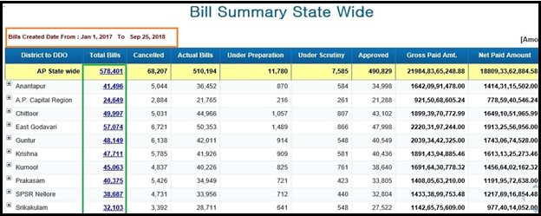

This Report consists of State wide total billsand District wide total bills, Cancelled bills, Actual bills, Under preparation, Under scrutiny, Approved bills, Gross paid amount, Net paid amount, Gross to be paid amount, Net to be paid amount.

Click on hyperlink, which is in **G*reen*** color box,it will be redirected to next Report i.e. Bills Type Detail Report.

Report also shows the selected time period in ***Orange*** color.

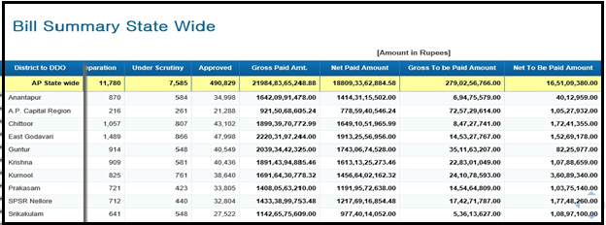

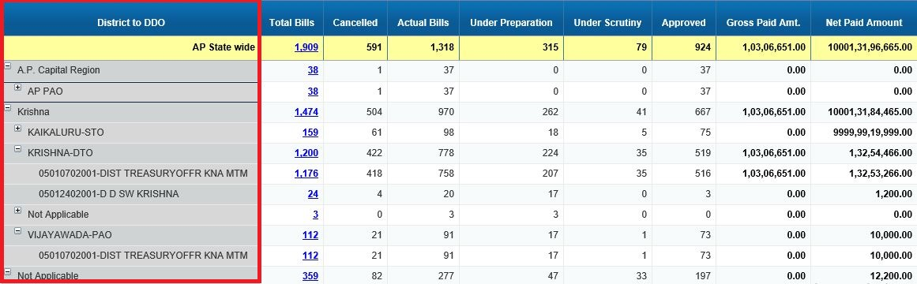

Clicking on District Hierarchy we go to next level which includes APAO, PAO, DTO, STO …etc.which is in **Red** color box.Further clicking on that hierarchy like PAO, DTO…etc we get detailed view of the report.

**List of Formulas used in Report Layer.**

|  |  |  |  |  |
| --- | --- | --- | --- | --- |
| **Column Names** | **Col Description** | **Colname formula** | **Col-Formula** | Ap State wide |
| **District to DDO** | **Hierachical drilldown from district to DDO level** | **=Char(10)+"District to DDO"** | **=[Fund Center Hierarchy]** | AP State wide |
| **Total Bills** | **District wise Total Bills** | **=Char(10)+NameOf([Total Bills])** | **=If([Total Bills]>0) Then ("<a href=\"../../opendoc/openDocument.jsp?iDocID=FrmWH1viHQsAc0UAAACnWmMAAFBWlxfh&sIDType=CUID&sType=wid&lang=EN_US&sRefresh=N&lsSpsHana%20Variable%20IP_DISTRICT="+URLEncode(""+[Fund Center Hierarchy].[DISTRICT] )+"&lsSpsHana%20Variable%20IP_FROM_DATE="+URLEncode(""+[From Date])+"&lsMpmHana%20Variable%20IP_MAJOR_HEAD="+URLEncode(""+If(Pos(ReportFilterSummary(); "Major Head") = 0 ) Then "" Else ReportFilter([Major Head (Code-Text)]))+"&lsSpsHana%20Variable%20IP_TO_DATE="+URLEncode(""+[To Date])+"&lsSpsHana%20Variable%20IP_TREASURY="+URLEncode(""+[Fund Center Hierarchy].[TREASURY])+"&lsSpsHana%20Variable%20IP_DDO="+URLEncode(""+[Fund Center Hierarchy].[DDO])+"&lsMpmHana%20Variable%20IP_GROUP_SUBHEAD="+URLEncode(""+(If(Pos(ReportFilterSummary(); "Group Sub Head") = 0 ) Then "" Else ReportFilter([Group Sub Head (Code-Text)])))+"&lsMpmHana%20Variable%20IP_BILL_TYPE="+URLEncode(""+(If(Pos(ReportFilterSummary(); "Bill Type") = 0 ) Then "" Else ReportFilter([Bill Type])))+"&lsMpmHana%20Variable%20IP_SUB_HEAD="+URLEncode(""+(If(Pos(ReportFilterSummary(); "Sub Head") = 0 ) Then "" Else ReportFilter([Sub Head (Code-Text)])))+"&lsMpmHana%20Variable%20IP_BILL_SUB_TYPE="+URLEncode(""+(If(Pos(ReportFilterSummary(); "Bill Sub Type") = 0 ) Then "" Else ReportFilter([Bill Sub Type])))+"&lsMpmHana%20Variable%20IP_HOA_DEPT="+URLEncode(""+(If(Pos(ReportFilterSummary(); "Department - HOA") = 0 ) Then "" Else ReportFilter([Department - HOA])))+"\" title=\"\" target=\"_blank\" nav=\"doc\">"+[Total Bills]+"</a>") Else 0** | **="<a href=\"../../opendoc/openDocument.jsp?iDocID=FrmWH1viHQsAc0UAAACnWmMAAFBWlxfh&sIDType=CUID&sType=wid&lang=EN_US&sRefresh=N&lsSpsHana%20Variable%20IP_FROM_DATE="+URLEncode(""+[From Date])+"&lsSpsHana%20Variable%20IP_TO_DATE="+URLEncode(""+[To Date])+"&lsMpmHana%20Variable%20IP_BILL_TYPE="+URLEncode(If(Pos(ReportFilterSummary(); "Bill Type") = 0 ) Then "" Else ReportFilter([Bill Type]))+"&lsMpmHana%20Variable%20IP_BILL_SUB_TYPE="+URLEncode((If(Pos(ReportFilterSummary(); "Bill Sub Type") = 0 ) Then "" Else ReportFilter([Bill Sub Type])))+"&lsMpmHana%20Variable%20IP_MAJOR_HEAD="+URLEncode(If(Pos(ReportFilterSummary(); "Major Head") = 0 ) Then "" Else ReportFilter([Major Head (Code-Text)]))+"&lsMpmHana%20Variable%20IP_GROUP_SUBHEAD="+URLEncode((If(Pos(ReportFilterSummary(); "Group Sub Head") = 0 ) Then "" Else ReportFilter([Group Sub Head (Code-Text)])))+"&lsMpmHana%20Variable%20IP_SUB_HEAD="+URLEncode((If(Pos(ReportFilterSummary(); "Sub Head") = 0 ) Then "" Else ReportFilter([Sub Head (Code-Text)])))+"&lsMpmHana%20Variable%20IP_HOA_DEPT="+URLEncode((If(Pos(ReportFilterSummary(); "Department - HOA") = 0 ) Then "" Else ReportFilter([Department - HOA])))+"\" title=\"\" target=\"_blank\" nav=\"doc\">"+[Total Bills]+"</a>"** |
| **Cancelled** | **District wise cancelled Bills** | **=Char(10)+"Cancelled"** | **=[Bills Cancelled]** | **=[Bills Cancelled]** |
| **Under preparation** | **Bills in district wise under preparation** | **=Char(10)+"Under Preparation"** | **=[Bills Under Preparation]** | **=[Bills Under Preparation]** |
| **Under scrutiny** | **Bills in district wise Under scrutiny** | **=Char(10)+"Under Scrutiny"** | **=[Bills Under Scrutiny]** | **=[Bills Under Scrutiny]** |
| **Approved** | **Bills Approved in district wise** | **=Char(10)+"Approved"** | **=[Bills Approved]** | **=[Bills Approved]** |
| **Gross paid amt** | **Total Gross amt paid in district wise** | **=Char(10)+NameOf([Gross Paid Amt.])** | **=If ([CurrencyFlag] = 1) Then ([Gross Paid Amt.])/10000000 Else If([CurrencyFlag] = 2) Then ([Gross Paid Amt.])/100000 Else ([Gross Paid Amt.])** | **=If ([CurrencyFlag] = 1) Then ([Gross Paid Amt.])/10000000 Else If([CurrencyFlag] = 2) Then ([Gross Paid Amt.])/100000 Else ([Gross Paid Amt.])** |
| **Net paid amt** | **Total Net amt paid in district wise** | **=Char(10)+NameOf([Net Paid Amount])** | **=If ([CurrencyFlag] = 1) Then ([Net Paid Amount])/10000000 Else If([CurrencyFlag] = 2) Then ([Net Paid Amount])/100000 Else ([Net Paid Amount])** | **=If ([CurrencyFlag] = 1) Then ([Net Paid Amount])/10000000 Else If([CurrencyFlag] = 2) Then ([Net Paid Amount])/100000 Else ([Net Paid Amount])** |
| **Gross to be paid amount** | **Gross amt to be paid** | **=Char(10)+NameOf([Gross To be Paid Amount])** | **=If ([CurrencyFlag] = 1) Then ([Gross To be Paid Amount])/10000000 Else If([CurrencyFlag] = 2) Then ([Gross To be Paid Amount])/100000 Else ([Gross To be Paid Amount])** | **=If ([CurrencyFlag] = 1) Then ([Gross To be Paid Amount])/10000000 Else If([CurrencyFlag] = 2) Then ([Gross To be Paid Amount])/100000 Else ([Gross To be Paid Amount])** |
| **Net to be Paid Amount** | **Net amt to be paid** | **=Char(10)+"Net To Be Paid Amount"** | **=If ([CurrencyFlag] = 1) Then ([Net To be Paid Amount])/10000000 Else If([CurrencyFlag] = 2) Then ([Net To be Paid Amount])/100000 Else ([Net To be Paid Amount])** | **=If ([CurrencyFlag] = 1) Then ([Net To be Paid Amount])/10000000 Else If([CurrencyFlag] = 2) Then ([Net To be Paid Amount])/100000 Else ([Net To be Paid Amount])** |

**Bill Summary Report Level User Prompts & Input Controls used.**

1. There is **six** User Prompt used in the Bill Summary Report.
2. From Date
3. To Date
4. District(optional)
5. Bill Type(optional)
6. Treasury(optional)
7. Department(optional)
8. There is **five** Input Control used in the Bill Summary Report.
9. Currency Scaling
10. Bill Sub Type
11. HOA
12. Group Sub Head
13. Sub Head

Appendix A--

Appendix B –